District Suchitwa Mission, Pathanamthitta
Best Practices to Manage COVID 19

Name of Urban Local Body: Thiruvalla

Title/ Category of Best Practice (some suggested categories include):
- Cleanliness/ sanitization of public places
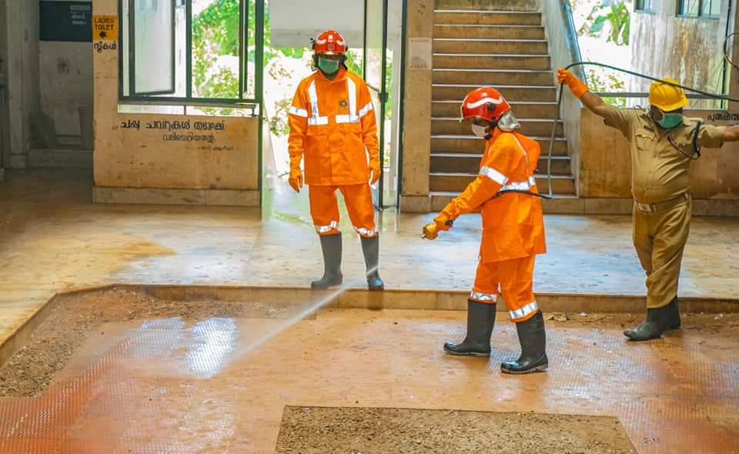
Disinfection activity at KSRTC Bus stand Thiruvalla
Description of Initiative:
- What are the key features of the initiative?
To clean all the public places in the municipality to avoid community spread of COVID 19
- Location/ region where initiative is being rolled out
KSRTC bus stand Thiruvalla Municipality
- How many people have been involved?
39 nos.

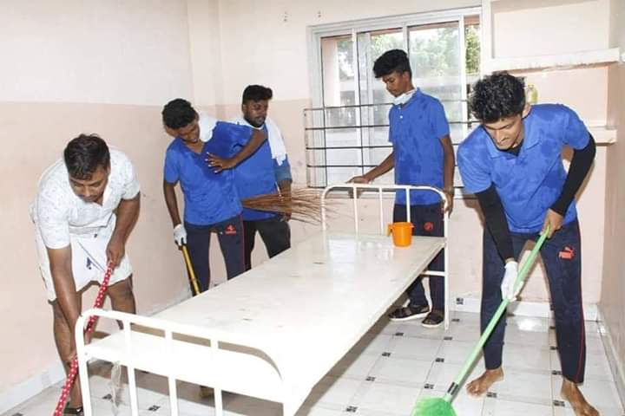
Disinfection activity at Taluke Hospital Tharuvalla
Description of Initiative:
- What are the key features of the initiative?
To clean all the public places in the municipality to avoid community spread of COVID 19
- Location/ region where initiative is being rolled out
Taluke Hospital Tharuvalla
- How many people have been involved?
45 nos.

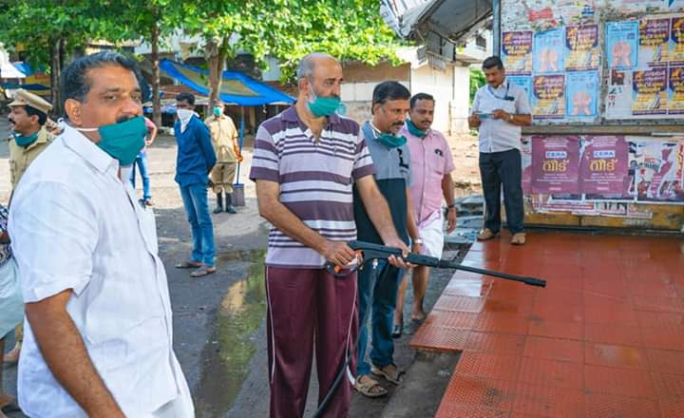
Disinfection activity at Kavumbhagom, Tharuvalla ULB

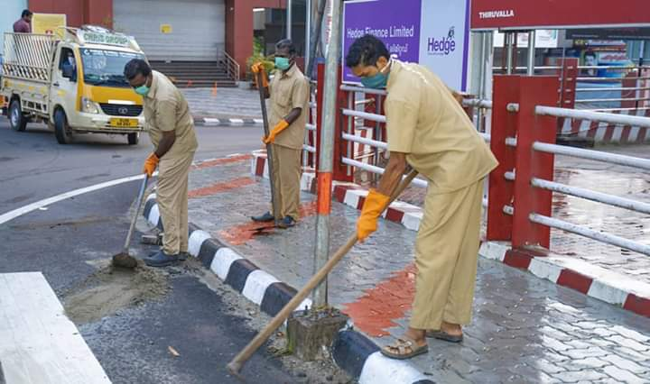
Disinfection activity at Tharuvalla

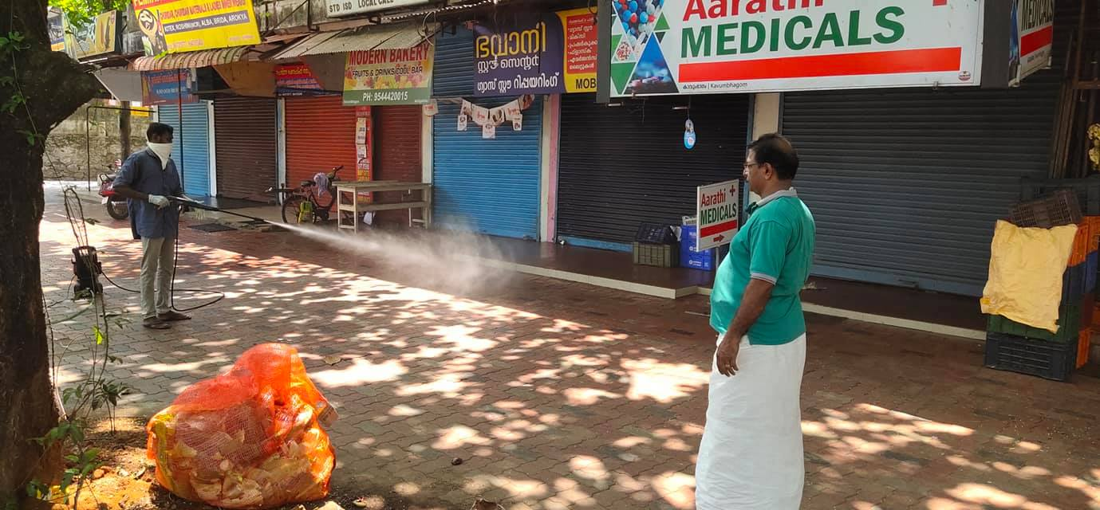
Disinfection activity at Thirumoolapuram, Tharuvalla ULB
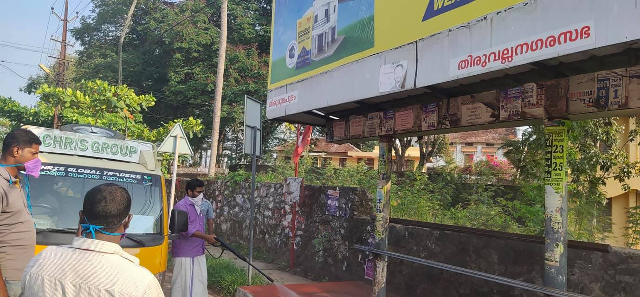
Disinfection activity at Kavumbhagom Bus stop

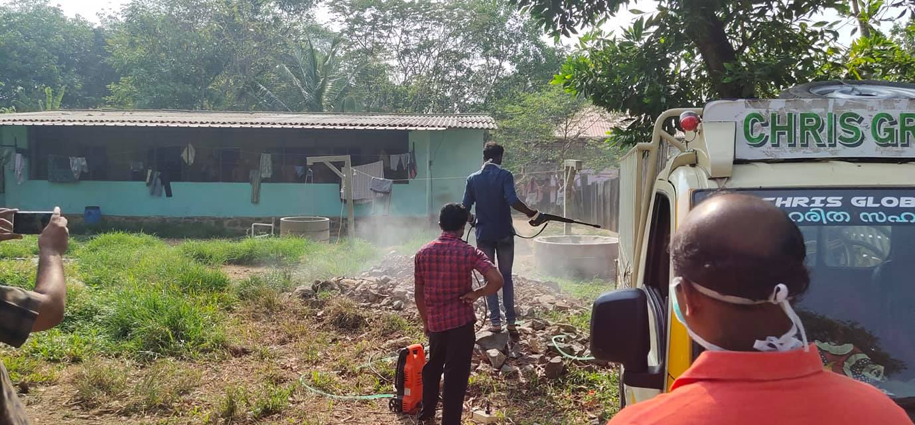
Disinfection activity at migrant labour camp, payippadu Thiruvalla

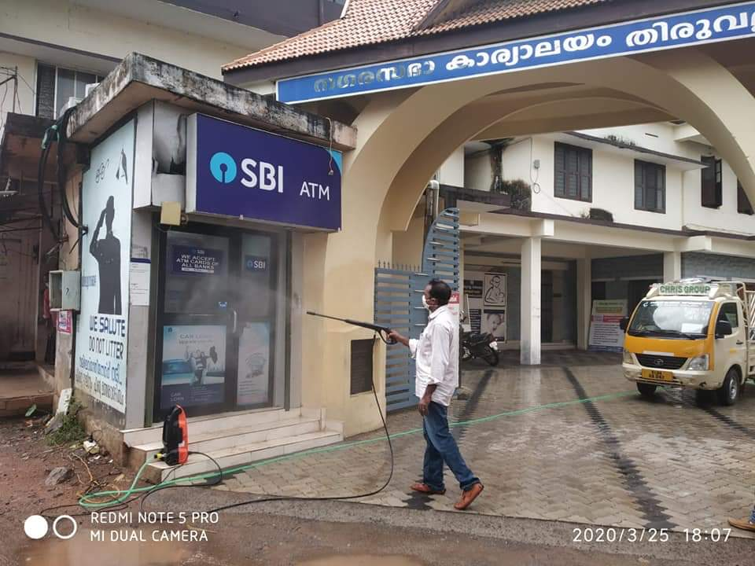
Disinfection activity at Thiruvalla municipal office

Description of Initiative:
- What are the key features of the initiative?
To clean all the public places in the municipality to avoid community spread of COVID 19
- Location/ region where initiative is being rolled out
Tharuvalla ULB
- How many people have been involved?
105 nos.

- IEC campaign to spread awareness on COVID 19
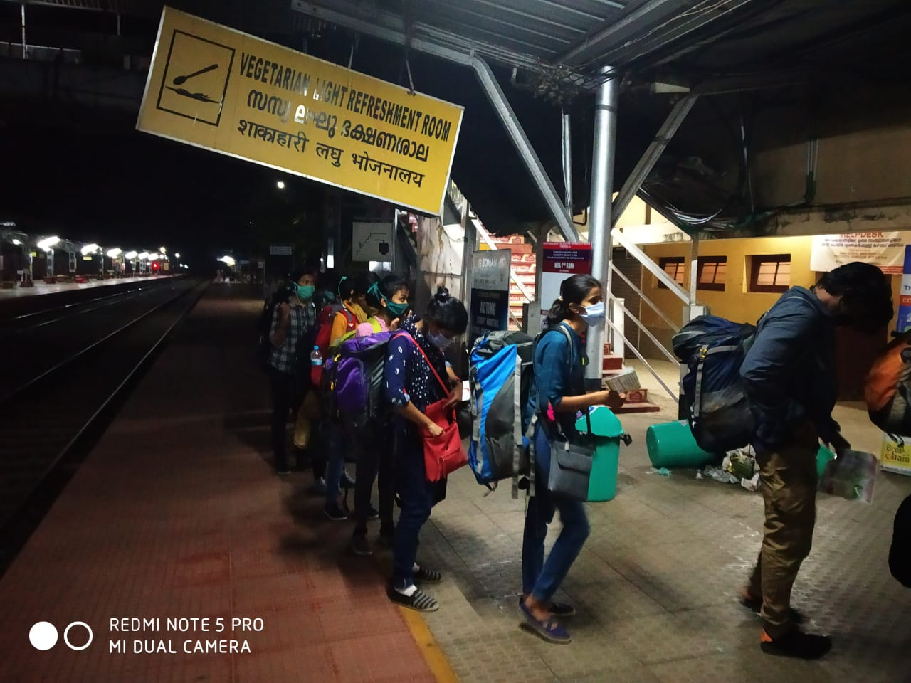
IEC leaflet distributed to passengers at Thiruvalla railway station
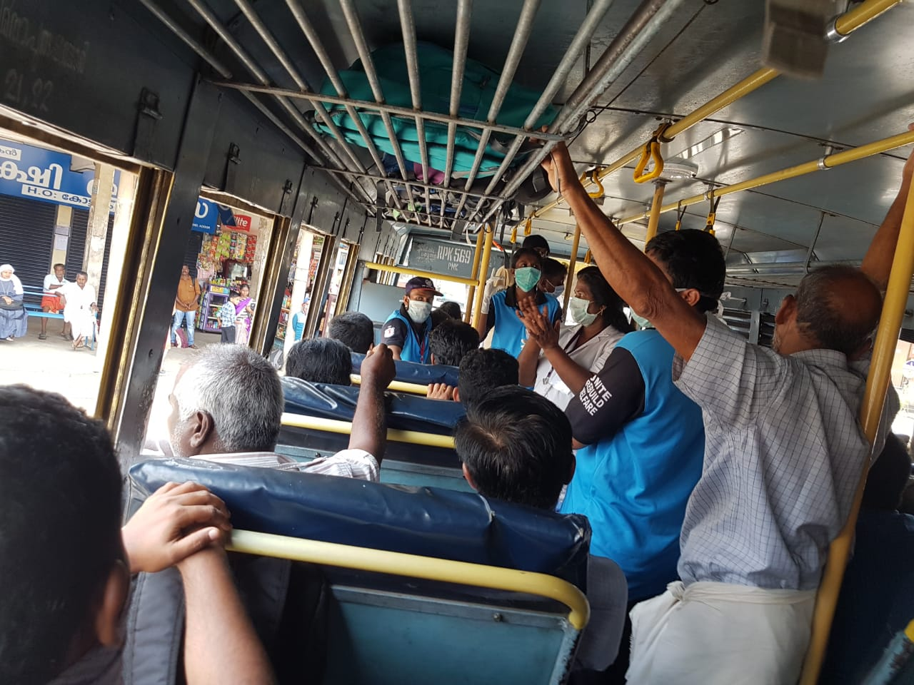
Public awareness programme at Private Buses

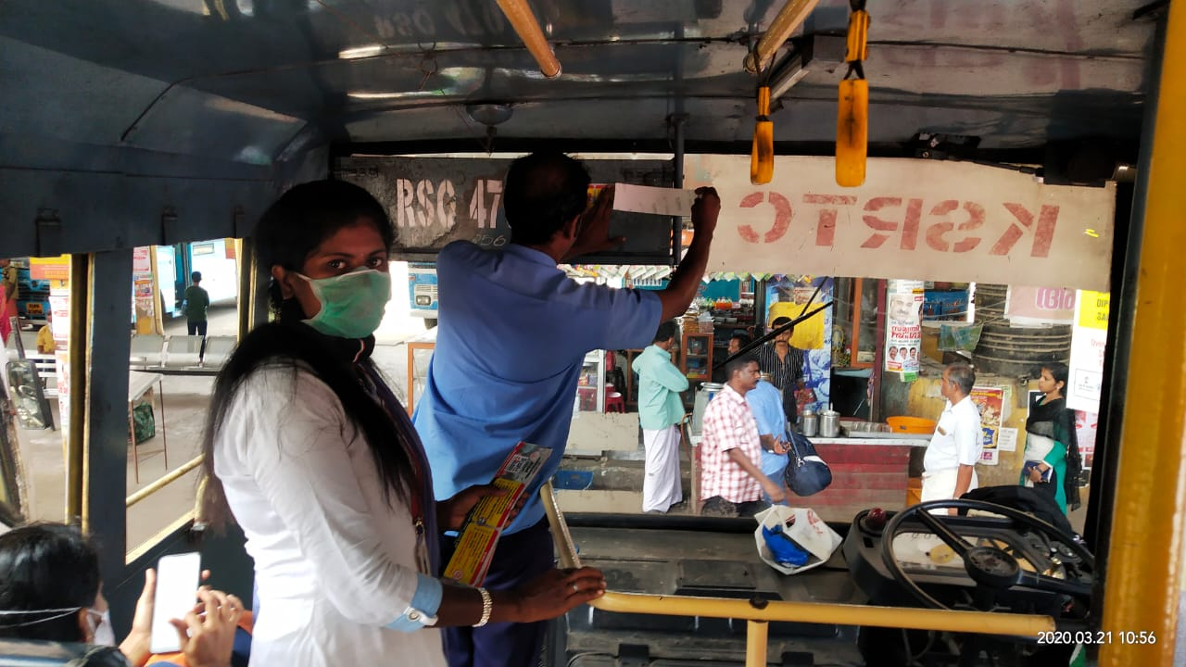
Public awareness programme at Private Buses

Description of Initiative:
- What are the key features of the initiative?
Awareness programme to public in the municipality to avoid community spread of COVID 19
- Location/ region where initiative is being rolled out
Thiruvalla Municipal area
- How many people have been involved?
94 nos.

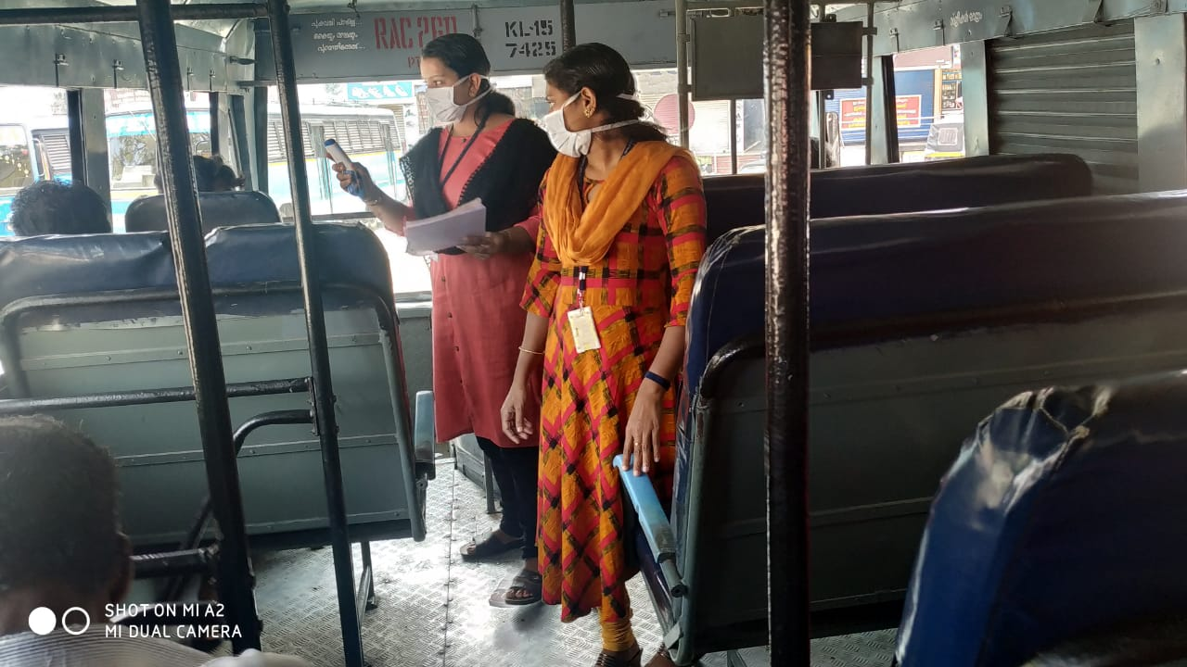
Medical check-up for passengers at KSRTC buses

Any news/ media coverage

Name and contact details of nodal person-
Sajikumar
Municipal Secretary, Thiruvalla
Mob- 7356670987, 8848978487

